**INSTALLING PYTHON PAKACGES**

NOW WE MUST CREATE A NEW FOLDER INISIDE OUR PROJECT, THAT FOLDER WILL HAVE ALL PROJECTS AND APPS OF DJANGO.:

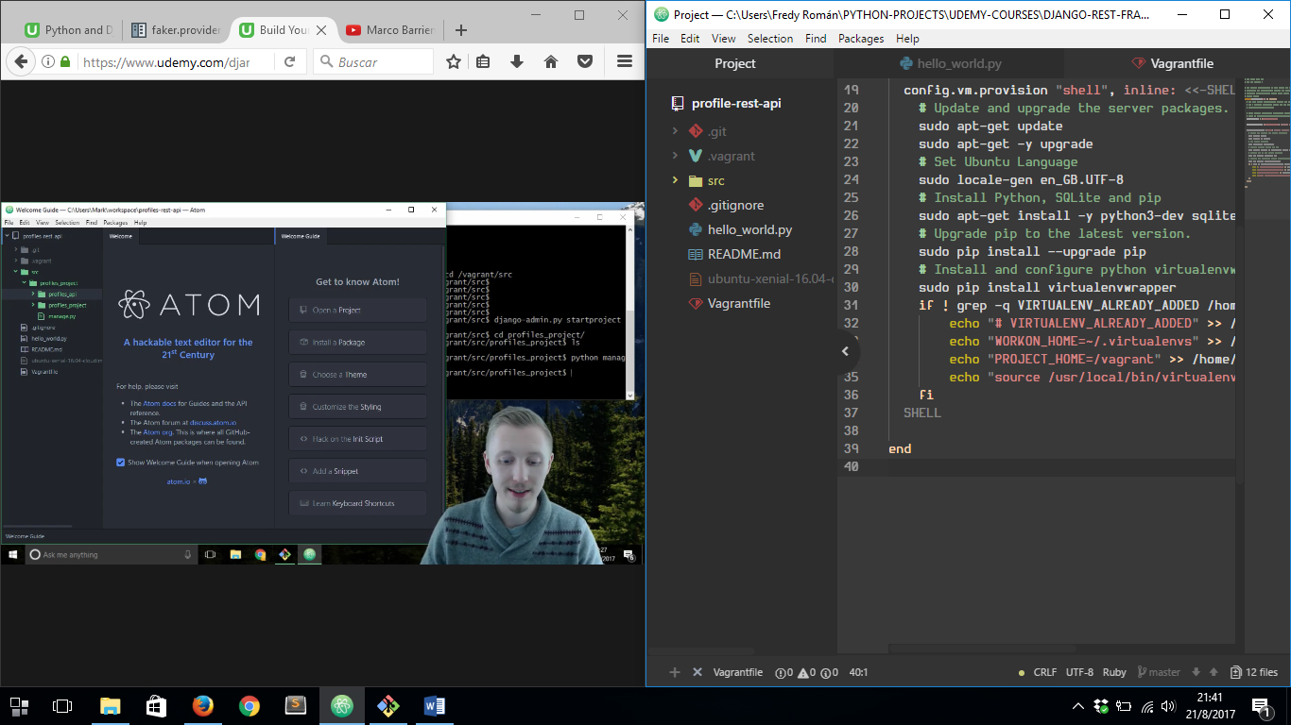

WHAT WE’RE GONNA DO NEXT IS ENTER INTO ***/vagrant/src*** FOLDER OF OUR PROJECT AND THEN RUN ***django-admin startproject “project_name”***

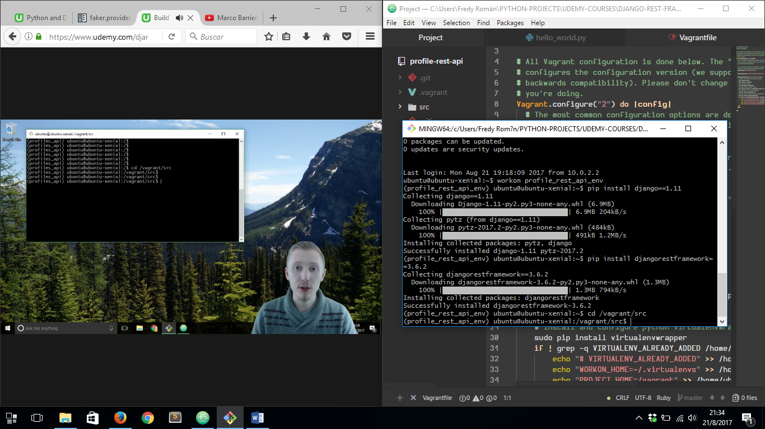

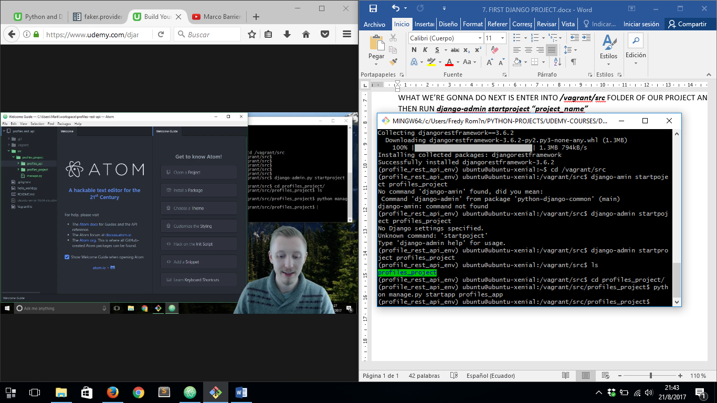

FINALLY, WE MUST ENTER INTO NEW PROJECT FOLDER AND THEN CREATE A NEW DJANGO APP.

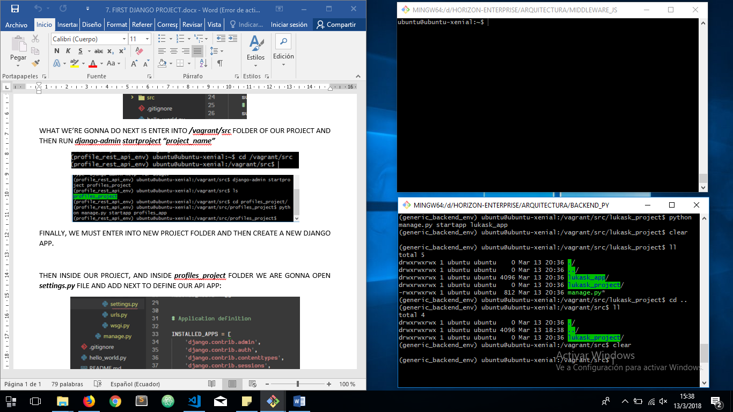

THEN INSIDE OUR PROJECT, AND INSIDE ***profiles_project*** FOLDER WE ARE GONNA OPEN ***settings.py*** FILE AND ADD NEXT TO DEFINE OUR API APP:

